PS Lab 06

IT24104332

Exercise

2. 
3. 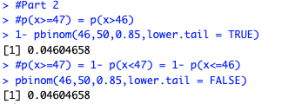
5. 
6. 
7. 